AIM:To study and implement the MD5 (Message Digest 5) hashing algorithm using Python.
ALGORITHM OF MD5:
- Import the hashlib library.

- Accept a message from the user.

- Encode the input message into bytes.

- Use hashlib.md5() to generate the hash value.

- Display the hash in hexadecimal format.

PROGRAM:-
import hashlib text = input("Enter text to hash: ") md5_hash = hashlib.md5(text.encode()) print("MD5 Hash Value:", md5_hash.hexdigest())

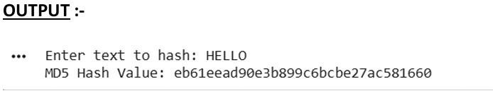
CONCLUSION :- MD5 is a simple and efficient hashing technique that converts input data into a fixed-length digest. It ensures data integrity by verifying whether data has been altered during transmission or storage.

